AI- SMART TRAFFIC MANAGEMENT SYSTEM WITH EMERGENCY VEHICLE PRIORITY
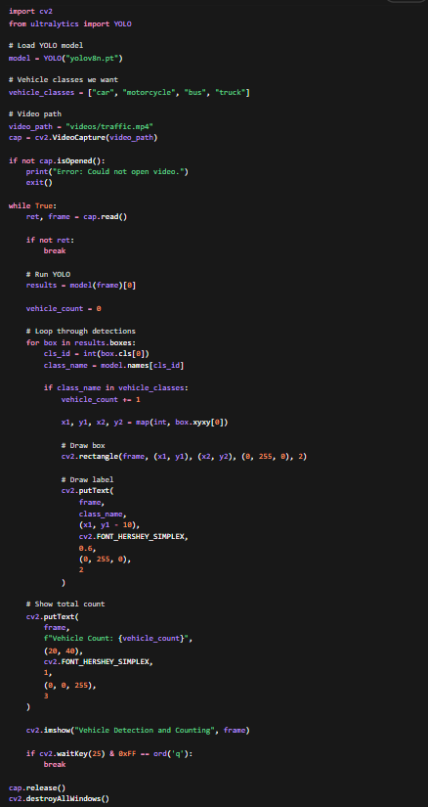
What this code is doing
vehicle_classes
This tells the system:
“Count only these objects as traffic vehicles.”
results = model(frame)[0]
This runs YOLO on one framefor box in results.boxes:
This checks every detected object one by one.class_name = model.names[cls_id]
This converts the class number into a real name like: car, truck or personif class_name in vehicle_classes:
This filters out unwanted things.So:
- person ❌
- dog ❌
- traffic light ❌
- car ✅
- bus ✅
vehicle_count += 1
This increases the count every time a vehicle is found.
FOR NOW WE HAVE DONE: Video → YOLO Detection → Vehicle Filter → Vehicle Count
NOW WE DIVIDE THE ROAD IN LANES AND DO LANE-WISE COUNTING
- Since the camera sees the whole road, we define fixed areas on screen
- So we are basically telling the computer: “If a detected vehicle lies inside this area, count it for that lane.”
NOW
1. frame.shape
This gives:
- frame height
- frame width
We need width so we can split the screen.2. lane_width = frame_width // 4
This divides the frame into 4 equal vertical parts.
If width = 1200, then:
- Lane 1 = 0 to 300
- Lane 2 = 300 to 600
- Lane 3 = 600 to 900
- Lane 4 = 900 to 1200
3. lane_counts
This dictionary stores the count for each lane.
lane_counts = {
"Lane 1": 0,
"Lane 2": 0,
"Lane 3": 0,
"Lane 4": 0
}4. center point of each vehicle
We calculate:
center_x = (x1 + x2) // 2
center_y = (y1 + y2) // 2
Why center point?
Because it is the easiest way to decide which lane the vehicle belongs to.5. Lane decision
We check where center_x lies.
Example:
- if center_x is small → left side → Lane 1
- if center_x is large → right side → Lane 4
6. Blue vertical lines
These show lane boundaries on screen.
So visually you can understand where each lane starts and ends.Important practical note
This works best when:
- camera angle is front-facing or top-ish
- lanes appear roughly vertical in the frame
If your video is slanted or intersection is angled, later we may need custom lane regions.
PRIORITY SYSTEM
Can YOLO detect “ambulance” directly?
Usually, the standard YOLO model detects common classes like:
- car
- truck
- bus
- motorcycle
- person
But it may not always have a separate ambulance class in the default model.
So for a student project, there are 2 ways:
Option 1: Practical beginner option
Treat certain large emergency-looking vehicles manually or use the label if available in your model/video.
Option 2: More advanced but better explained
Say:
At prototype level, emergency vehicle recognition can be approximated using class-based or appearance-based identification. In future work, a custom-trained ambulance detector can be used.For now, since we are building step by step, we will first create the priority logic framework.
That means:
- if an emergency vehicle is detected in any lane
- that lane gets green immediately
Later, if needed, we can refine the actual detection method.Best beginner approach for now
We will simulate emergency detection in a simple and explainable way.
For now:
- assume bus acts as emergency vehicle placeholder
or
- define a manual trigger key for testing
The manual trigger first, because it lets you test the priority logic properly without being blocked by model limitations.
This is actually a smart engineering approach:
- first test the control logic
- then improve the detection module
So what we’ll build now
We will add:
- a manual emergency trigger
- choose which lane has emergency
- override normal signal logic
Example:
- press 1 → emergency in Lane 1
- press 2 → emergency in Lane 2
- press 3 → emergency in Lane 3
- press 4 → emergency in Lane 4
- press 0 → clear emergency mode
Then:
- selected lane immediately becomes GREEN
- others become RED
- countdown can show emergency mode
Right now, there is one issue:
👉 Same lane can get green repeatedly
👉 Other lanes may starve
“To avoid starvation, we introduced fairness by preventing the same lane from being selected consecutively unless it has significantly higher traffic”.
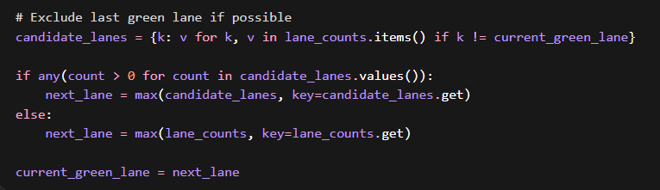
🧠 What This Does
- tries to pick a different lane
- unless all other lanes are empty
- prevents unfair dominance
OUR PROJECT TILL NOW:
Detection → Counting → Smart Timing → Fair Selection → Emergency Override
🧠 1. 30-Second Project Explanation (Use This)
If examiner says: “Explain your project”
Say this:
Our project is an AI-based smart traffic management system that dynamically adjusts signal timings based on real-time traffic density using computer vision. We use a YOLO-based object detection model to detect and count vehicles in each lane from video input. Based on the vehicle count, we calculate adaptive green signal durations instead of fixed timing, which reduces congestion and waiting time. Additionally, we implemented an emergency vehicle priority system that overrides normal signal operation and immediately gives green signal to the emergency lane. This system improves traffic efficiency and can be extended for smart city applications.

🧠 2. System Flow (Explain Like This)
If they ask: “How does your system work?”
1. Capture video from traffic camera
2. Detect vehicles using YOLO
3. Count vehicles lane-wise
4. Calculate traffic density
5. Assign green signal dynamically
6. Apply fairness logic
7. Override using emergency priority if needed

🧠 3. Key Features (Say These Confidently)
- Real-time vehicle detection
- Lane-wise density estimation
- Dynamic signal timing (not fixed)
- Fair traffic scheduling
- Emergency vehicle override

🧠 4. Most Important Question (They WILL Ask)
❓ “Why is your system better than existing traffic signals?”
👉 Answer:
Traditional traffic systems use fixed-time signals which do not adapt to real-time traffic conditions, leading to unnecessary waiting and congestion. Our system dynamically adjusts signal timing based on actual vehicle density, ensuring efficient traffic flow. It also prioritizes emergency vehicles, which is not handled in conventional systems.

🧠 5. Technical Question
❓ “Why did you use YOLO?”
👉 Answer:
We used YOLO because it provides real-time object detection with high accuracy and speed. It is suitable for live traffic analysis as it can detect multiple vehicles in a single frame efficiently.

🧠 6. Smart Answer (HIGH IMPACT)
❓ “Why vertical lane division?”
👉 Answer:
For our prototype, we used vertical segmentation for simplicity and real-time performance. However, we also explored perspective-based polygon lane mapping, which can improve accuracy in real-world deployments.
👉 This shows:
- you know limitations
- you know improvements

🧠 7. Limitations (VERY IMPORTANT)
Say this:
The current system uses a pre-trained model and does not specifically distinguish emergency vehicles like ambulances. Lane segmentation is approximate due to camera perspective. Also, real-world deployment would require integration with hardware signals and multiple camera feeds.

🧠 8. Future Improvements
Future improvements include training a custom model for ambulance detection, using perspective-based lane detection, integrating IoT for real-time signal control, and applying reinforcement learning for optimized traffic scheduling.
**THIS IS JUST A PROTOTYPE FOR THE STARTING, WE HAVE DONE MANNUAL TRIGGERING SYSTEM FOR THE EMERGENCY VEHICLE, LATER WE WILL USE AUTOMATIC EMERGENCY VEHICLE DETECTION **

